FARM MANAGEMENT SYSTEM
Project Documentation
User Story:
In the Farm Management System (FMS), as a farmer, farm manager, or system administrator, I want to use a centralized Salesforce-based platform to record and manage farm, crop, farmer, and buyer information so that all agricultural data is stored securely and systematically. I want to enter and update farm details, crop production records, and buyer transactions easily through a user-friendly interface with proper validation rules to prevent incorrect entries. I also want the system to generate real-time reports and interactive dashboards so that I can analyze farm productivity, monitor sales, and make informed decisions. Additionally, I want role-based access and secure data storage to ensure that sensitive information is protected while enabling smooth collaboration among users. This system will help reduce manual paperwork, minimize errors, improve efficiency, and support data-driven farm management

1. Introduction
Farm Management System is a Salesforce-based application designed to help manage important farming-related information in a centralized system. The system can be used to maintain farm and crop information, manage users, organize records, and generate reports and dashboards for better monitoring.

2. Problem Statement
Managing farm information manually can be time-consuming and may lead to duplicate, missing, or difficult-to-track records. A centralized digital system is required to organize farm-related data, control access to records, and provide useful reports for monitoring.

3. Objectives
- To create a centralized system for managing farm-related information.
- To organize records using Salesforce objects, fields, and relationships.
- To provide controlled access using profiles, roles, and sharing rules.
- To create reports and dashboards for easy data analysis.
- To provide a simple and structured application for users.

4. Existing System
In a manual system, farm records may be maintained using notebooks, spreadsheets, or separate files. Searching and updating information can take more time, and it may be difficult to control access and prepare reports.

5. Proposed System
The proposed Farm Management System uses Salesforce to store and manage information in a structured way. The system includes customized objects, tabs, fields, relationships, user access settings, reports, and dashboards. This provides a single place to manage and monitor project data.

6. Technology Used
Technology | Purpose
Salesforce | Cloud platform used to build the application
Lightning App | Application interface for users
Salesforce Objects | Store and organize project records
Reports | Analyze and summarize records
Dashboard | Display important information visually

7. System Modules
Module | Description
User Story | Defines the requirement from the user's point of view.
Salesforce Account Creation | Provides the Salesforce environment required for the project.
Objects | Stores structured farm management records.
Tabs | Provides navigation to the required objects.
Lightning App | Combines the required components into an application.
Fields and Relationships | Stores required information and connects related records.
Profile and Role | Controls user permissions and hierarchy.
Users | Manages users who access the application.
Sharing Rules | Controls record access between users.
User Adoption | Supports user usage and acceptance of the application.
Reports | Provides summarized information from records.
Dashboard | Displays key information in an easy-to-understand format.

8. Salesforce Configuration
The project configuration includes the creation and setup of Salesforce objects, tabs, a Lightning application, custom fields and relationships, profiles, roles, users, sharing rules, reports, and dashboards. These components work together to provide the required Farm Management System.

9. Fields and Relationships
Custom fields are used to capture the information required by the application. Relationships connect related records so that information can be accessed and analyzed together. The exact field names and relationships should be updated in this document according to the final project configuration.

10. User Access Management
Profiles define what users are allowed to do in Salesforce. Roles help establish the user hierarchy, while sharing rules provide additional control over record visibility. Together, these settings help maintain secure and organized access to project data.

11. Reports and Dashboard
Reports are created to summarize and analyze the records stored in the system. A dashboard can present important report information in a visual format, helping users monitor the system more easily.

12. Testing
The main project components should be tested to confirm that users can access the application, records can be created and updated according to permissions, relationships work correctly, and reports and dashboards display the expected information.
Test Case | Expected Result | Status
Open Lightning App | Application opens successfully | Pass
Create/Update Record | Record is saved according to permissions | Pass
Check User Access | User receives the configured access | Pass
Open Report | Report displays available records | Pass
Open Dashboard | Dashboard displays configured components | Pass

13. Project Screenshots
Insert screenshots of the completed Salesforce project in this section. Suggested screenshots: Lightning App, Objects/Tabs, Fields and Relationships, Profile, Role, Users, Sharing Rules, Reports, Dashboard, and final project view.
Screenshot 1 – Lightning App
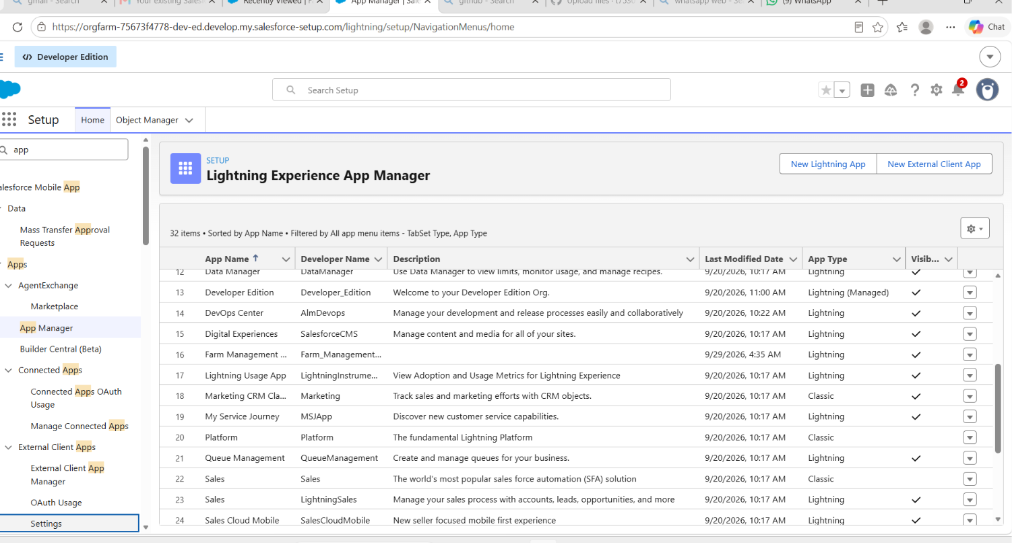
Screenshot 2 – Objects and Tabs
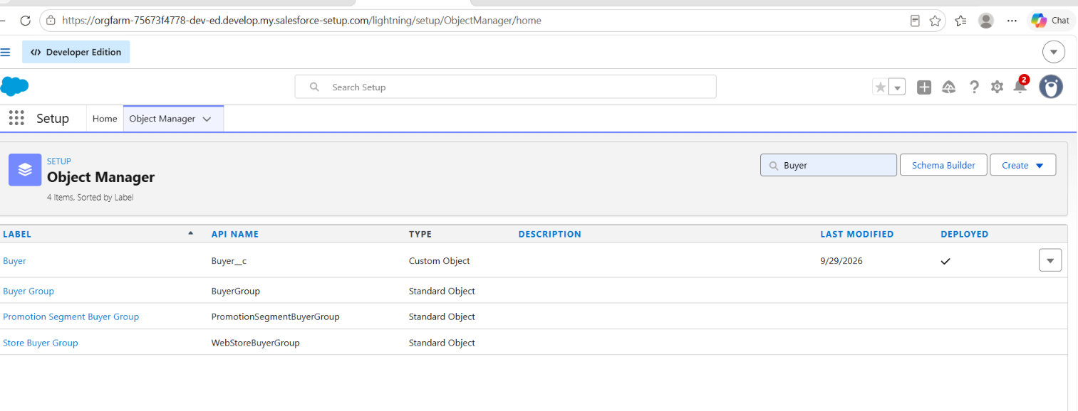
Screenshot 3 – Fields and Relationships
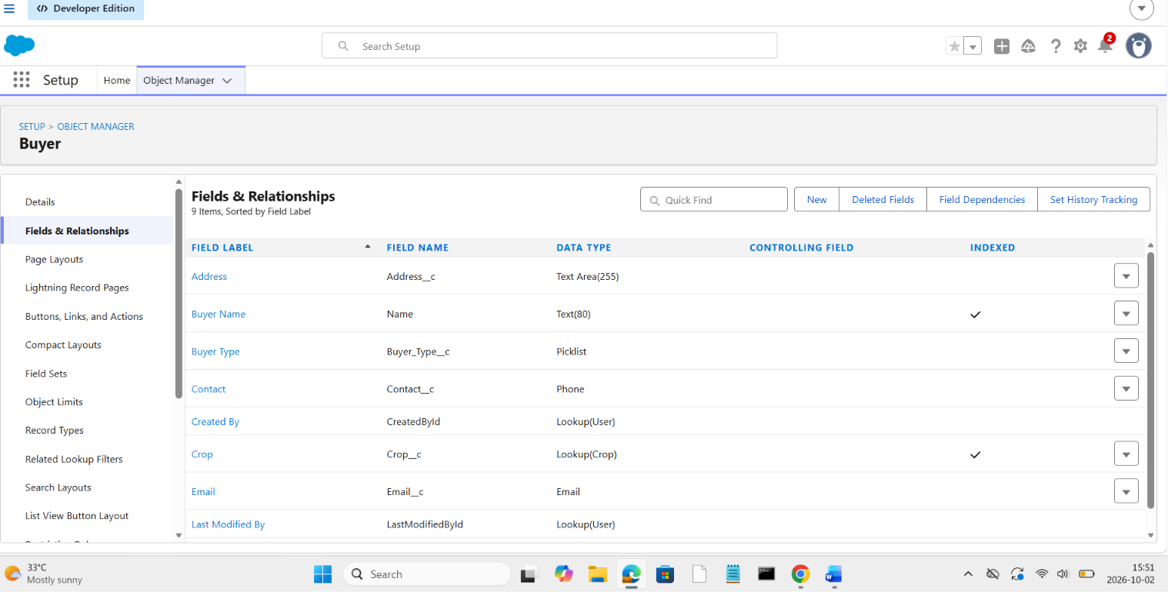
Screenshot 4 – Profile, Role and Users
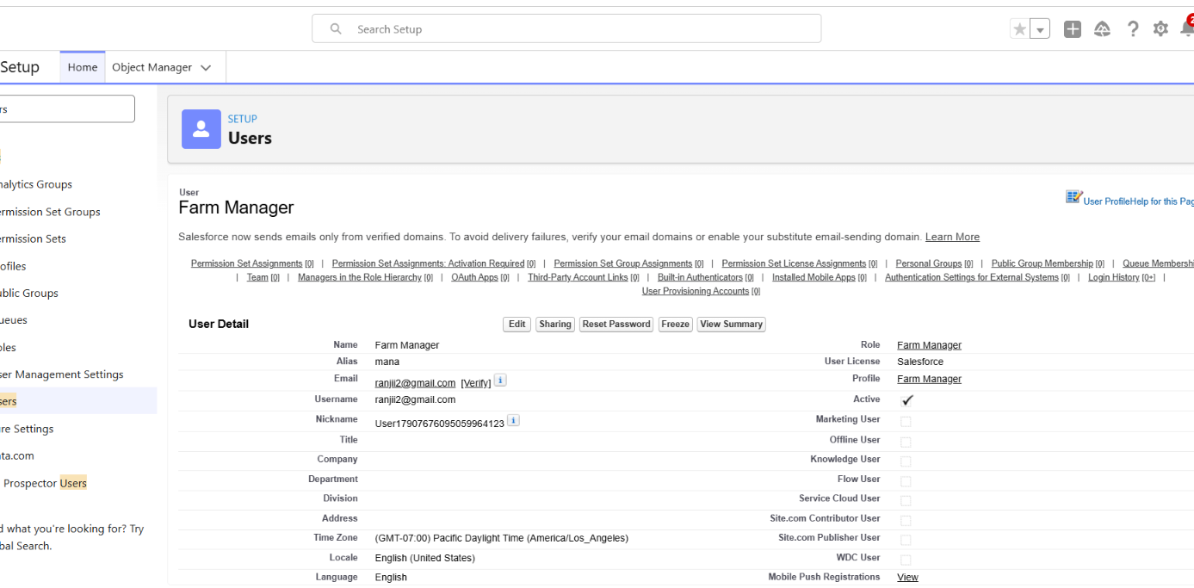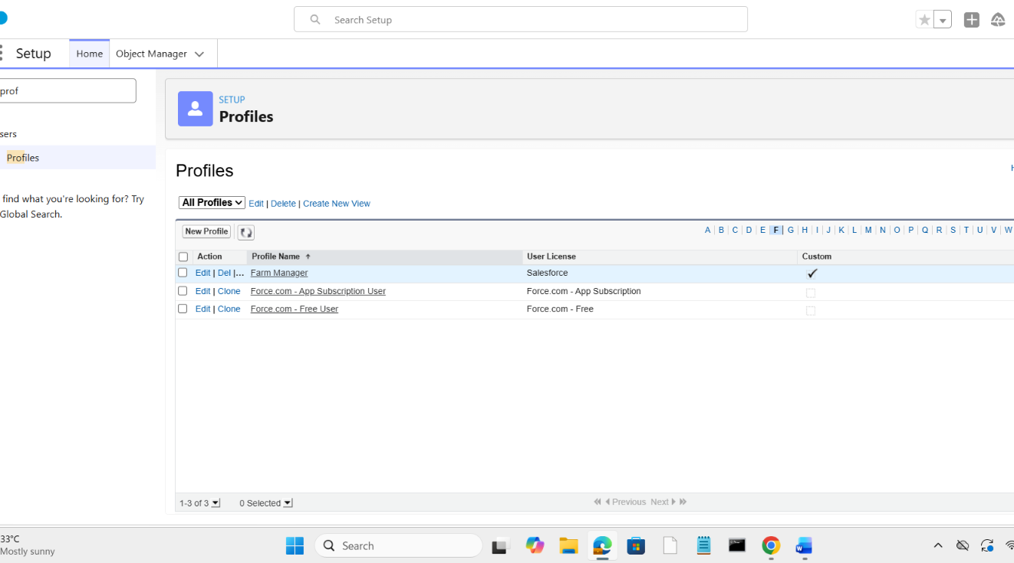
Screenshot 5 – Reports
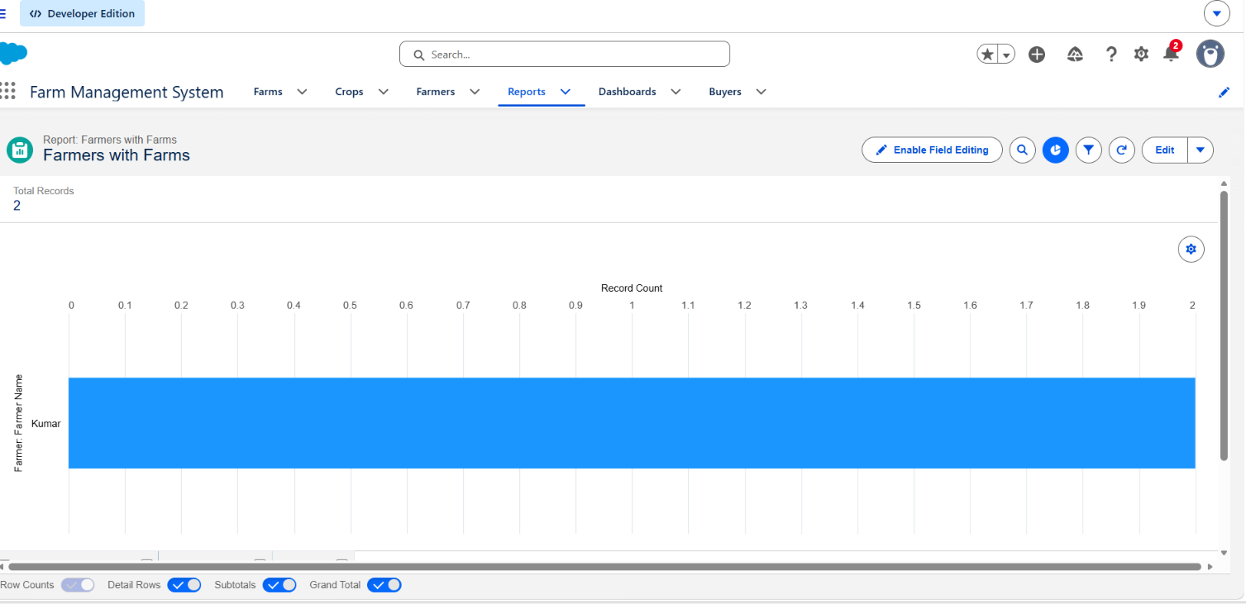
Screenshot 6 – Dashboard
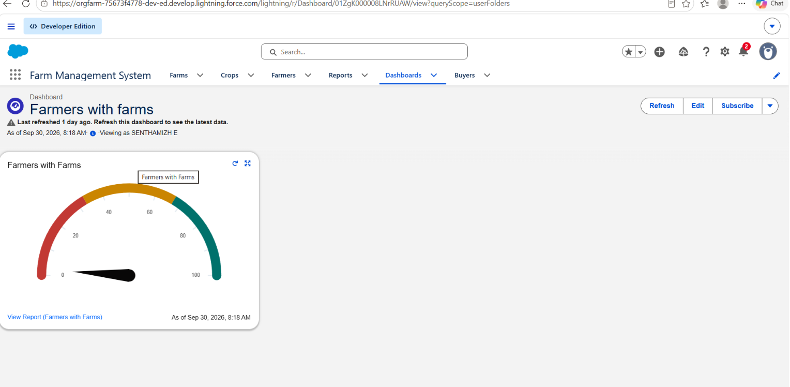

14. Conclusion
The Farm Management System provides a structured Salesforce-based solution for organizing and managing farm-related information. By using Salesforce configuration, access control, reports, and dashboards, the project provides a centralized and manageable environment for the intended users.

15. Future Enhancements
- Add mobile-friendly features for field users.
- Add notifications and reminders for important farm activities.
- Add more advanced reports and dashboards.
- Integrate additional data sources when required.
- Add automation to reduce repetitive manual work.

16. References
- Salesforce Trailhead – Salesforce learning resources.
- Salesforce Platform documentation.
- Naan Mudhalvan project instructions and project workspace.

